PART I (80 marks)
2002 TEE

Mark your answers to Questions 1–40 on the SEPARATE MULTIPLE CHOICE ANSWER SHEET, using a 2B, B or HB pencil. If you make an error, follow the instructions given to you on the answer sheet.

SELECT THE SINGLE CORRECT ALTERNATIVE IN EACH OF THE FOLLOWING QUESTIONS

Note: This figure is to be used for questions 1 and 2.
D

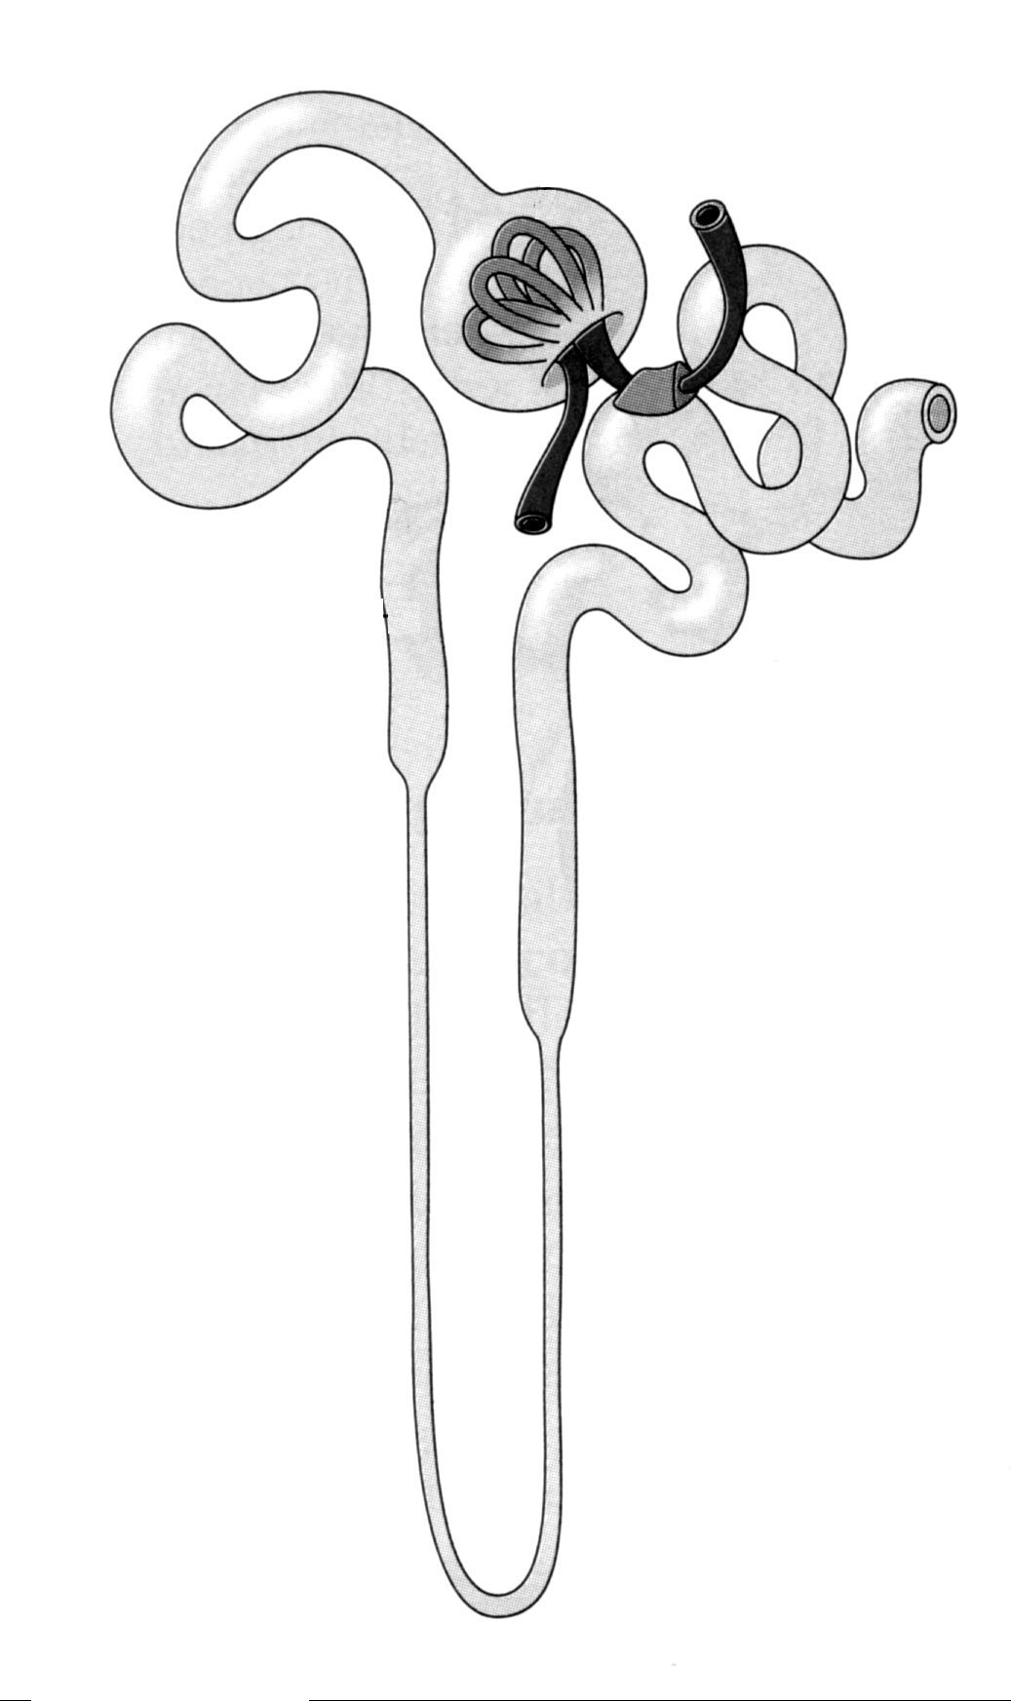
A
B
C

1. Identify the structure labelled B.

- (a) Glomerular capsule
(b) Proximal convoluted tubule
(c) Distal convoluted tubule
(d) Loop of Henle

2. In which of the labelled structures does ACTIVE reabsorption of glucose occur?

- A
- B
- C
- D

3. Which of the following lists the vessels in the correct order of blood flow?

(a) Afferent arteriole, glomerulus, peritubular capillaries, efferent arteriole.
(b) Afferent arteriole, glomerulus, efferent arteriole, peritubular capillaries.
(c) Efferent arteriole, glomerulus, peritubular capillaries, afferent arteriole.
(d) Peritubular capillaries, efferent arteriole, glomerulus, afferent arteriole.

4. Which of the following hormones regulates sodium ion concentrations in extracellular fluid?

(a) Aldosterone
(b) Insulin
(c) ADH
(d) Testosterone

5. Deamination is a chemical process in which

(a) protein is synthesised.
(b) the amino group is metabolised to produce energy.
(c) urea is broken down to produce ammonia.
(d) the amino group is removed from the amino acid.

6. The mammary glands are an important target for

(a) oxytocin.
(b) follicle-stimulating hormone.
(c) luteinizing hormone.
(d) glucagon.

7. The anterior pituitary gland releases luteinizing hormone in response to

(a) prolactin release from neighbouring pituitary cells.
(b) corticotrophin-releasing factor from the hypothalamus.
(c) ADH from the posterior pituitary gland.
(d) gonadotrophin-releasing factor from the hypothalamus.

8. Which of the following is part of a POSITIVE feedback loop?

(a) Follicle-stimulating hormone stimulation of follicle growth.
(b) Thyroid-stimulating hormone stimulation of thyroxine secretion.
(c) Oestrogen stimulation of luteinizing hormone secretion.
(d) Luteinizing hormone stimulation of progesterone secretion.

9. Examine the diagram below that shows light rays entering an eye. What condition is illustrated in this diagram and how is this corrected?

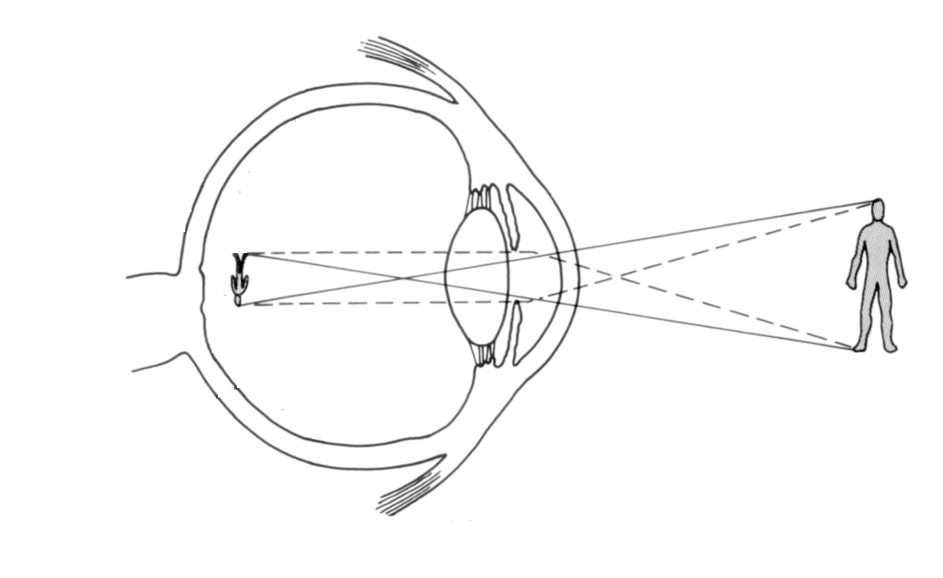

(a) Myopia, corrected with a concave lens.
(b) Myopia, corrected with a convex lens.
(c) Hypermetropia, corrected with a concave lens.
(d) Hypermetropia, corrected with a convex lens.

10. Which statement about nerve fibres is correct?

(a) Fibres that have a larger diameter will conduct impulses slower than those with a smaller diameter.
(b) Myelinated fibres conduct impulses slower than unmyelinated nerve fibres.
(c) Nodes of Ranvier increase the speed of nerve impulse transmission.
(d) All myelinated nerve fibres end on skeletal muscle fibres.

11. The cerebellum does NOT control

(a) posture.
(b) coordination.
(c) balance.
(d) body temperature.

12. Which statement about the retina is correct?

(a) Each retina has about 7 million rods and 120 million cones.
(b) Cones provide black and white vision in bright light.
(c) Cones are found in the greatest concentration in the fovea centralis.
(d) Rods aid in colour vision when the light is dim.

Note: The next two questions refer to the pedigree below.

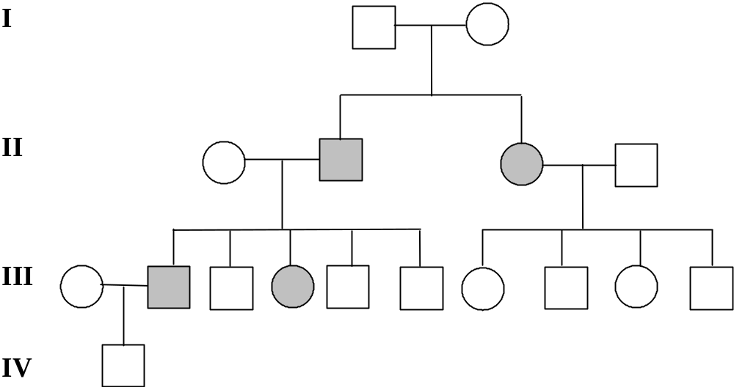

13. The pedigree above shows the inheritance of a trait in a family. What is the most likely mode of inheritance of this trait?

(a) X-linked recessive
(b) X-linked dominant
(c) Autosomal recessive
(d) Autosomal dominant

14. What is the probability that individual IV.1 is a carrier of the trait?

(a) 0%
(b) 25%
(c) 50%
(d) 100%

Note: The next two questions refer to haemophilia, an X-linked recessive condition.

15. If an affected (i.e. haemophiliac) male and unaffected female (who is NOT a carrier) have a child, what is the probability that this child will be affected?

(a) 0%
(b) 25%
(c) 50%
(d) 75%
16. What are the possible genotypes for the female offspring of a female carrier of the trait and a normal male?

(a) X^{h}X^{h} only
(b) X^{h}Y only
(c) X^{h}X^{H} or X^{H}X^{H}
(d) X^{h}X^{h} or X^{H}X^{H}

17. A scientist visiting some offshore islands identified 10 different species of butterflies. The scientist concluded that these had descended from an original population that arrived from the mainland and then spread throughout the islands.

Which of the following would account for the development of the 10 species of butterfly?

(a) The different butterfly populations were able to interbreed freely.
(b) There was variation between individuals in the original population.
(c) There was little variation among habitats on the islands.
(d) The original population was not typical of the mainland butterflies.

18. A mutation is a sudden change in the structure of a gene. Scientists link mutations to the process of natural selection very closely. Mutations

(a) always produce beneficial variations upon which natural selection can act.
(b) are of importance to natural selection only if they can pass from generation to generation.
(c) will improve the survival chances of an individual.
(d) result in random genetic drift.

19. A small island in the Pacific was studied and the population was found to carry an
abnormally high frequency for the gene causing Achromatoplasia (absence of colour
vision). Scientists concluded that this was due to random genetic drift.

Which of the following is the best example of how random genetic drift may have caused this result?

(a) A cyclone struck the island suddenly. Most of the survivors carried the gene for Achromatoplasia.
(b) The gene for Achromatoplasia gives a survival advantage to those who possess it.
(c) Those who carry this gene are more likely to find mates and more likely to have children.
(d) There has been a large growth of the population in recent years.

20. An isotope has a half-life of 310⁶ years. In 610⁶ years

(a) half the original amount of isotope will be present.
(b) all of the original isotope will be present.
(c) one quarter of the original isotope will remain.
(d) one eighth of the original isotope will remain.

21. Of the following, the best suited for carbon-14 dating techniques is

(a) metals.
(b) materials older than 100,000 years.
(c) limestone.
(d) some materials less than 75,000 years old.

22. The greatest likelihood of fossilisation occurring is in

(a) teeth.
(b) long bones.
(c) connective tissue.
(d) cartilage.

23. A person is able to hear noises of a high frequency but is unable to hear noises of a low frequency. The most likely area of ear damage is the

(a) oval window.
(b) semicircular canals.
(c) ossicles.
(d) cochlea.

24. Compared to Neanderthals, modern humans

(a) have much larger brains.
(b) have a higher skull with a more vertical forehead.
(c) are more muscular.
(d) have more teeth.

Note: The next two questions refer to the diagram below.

A
Modulator
C
D
Stimulus: Rise in body temperature

25. The diagram above represents a homeostatic loop model. In general terms A and C
refer to

(a) receptor and negative feedback.
(b) receptor and effector.
(c) receptor and response.
(d) response and mode of transmission.

26. An appropriate effector in this loop would be

(a) thermoreceptors in the skin.
(b) blood vessels in the skin.
(c) sebaceous glands in the skin.
(d) the pituitary gland.
27.
Drop in blood CO₂
Chemoreceptors
Medulla
Diaphragm
Breathing rate
Rise in blood CO₂

The sequence of events shown in the diagram above is best described as a

(a) reflex action.
(b) hormonal pathway designed to maintain CO₂ at a set level.
(c) positive feedback because the CO₂ increases.
(d) negative feedback because the rise in CO₂ is opposite to the initial stimulus.

28. The heart rate can be increased by stimulating

(a) somatic nerves.
(b) cranial nerves.
(c) parasympathetic nerves.
(d) sympathetic nerves.

29. Insulin will maintain blood glucose at homeostatic levels by

(a) decreasing the formation of glycogen.
(b) increasing the breakdown of glycogen.
(c) increasing the formation of glycogen.
(d) stimulating the formation of glucose.

30. The cells of the pancreas which secrete glucagon are the

(a) delta cells.
(b) alpha cells.
(c) beta cells.
(d) gamma cells.

31. Darker pigmentation of the skin confers an advantage in equatorial regions because it

(a) allows the maximum absorption of ultraviolet radiation, helping to synthesise vitamin D.
(b) prevents all skin cancers.
(c) gives protection against ultraviolet radiation.
(d) stops rickets.

32. Aboriginal settlement of Australia is widely accepted to have occurred more than 40,000 years ago. However, the origins of Aboriginal migration are still debated. Of the following, which is the most likely area, according to current research, from which they migrated to arrive here?

(a) Iraq
(b) China
(c) Europe
(d) Africa

33. Skin colour in humans

(a) is continuous in variation.
(b) appears in three basic colours.
(c) appears in five basic colours.
(d) is between three and seven basic colours, but the exact number is unclear.

34. The antibiotic Vancomycin would be least effective at combating

(a) a foot infection caused by a large splinter.
(b) a sore throat caused by the Staphylococcus bacterium.
(c) the measles virus.
(d) severe food poisoning.

35. Pus is formed when special cells of the immune system enter a site of infection and ingest or engulf foreign matter. These cells are called

(a) T cells.
(b) phagocytes.
(c) lymphocytes.
(d) antigens.

36. Which of the following is the best description of disease transmission by a vector?

(a) The spread of hepatitis in drug addicts through the shared use of needles.
(b) A throat infection spreading through a pre-school as students use a common drinking fountain.
(c) Cystic fibrosis is an inherited condition passed from parents to offspring.
(d) An influenza outbreak in Japan reaching Australian shores carried by birds that migrate south.

37. Assuming no migration, population growth occurs when

(a) birth rates are greater than death rates.
(b) birth rates are equal to death rates.
(c) birth rates are less than death rates.
(d) birth rates are zero.
38. During the last century, increasing levels of industry and agriculture have led to the pollution and degeneration of local waterways. Which of the following is a valid example of this?

(a) Heavy metal pollution decreasing O₂ levels in waterways.
(b) Fertiliser run off into waterways causing algal blooms.
(c) Excessive greenhouse gases causing water temperature to rise.
(d) Excessive nutrients causing fish deformities.

39. In the early years of last century, scientists concluded that there would be massive loss of human life during the twentieth century as the ability of the earth to support life was outstripped by predicted population growth. The major reason this has not occurred is because

(a) high levels of urbanisation have limited the spread of humans across the planet.
(b) of the introduction of effective fertilisers and high yield wheat and rice grains.
(c) widespread use of birth control has reduced the world’s population.
(d) the effects of pollution on the environment have not been as bad as expected.

40. A high fertility rate in a population may cause it to grow rapidly. Fertility rate refers to

(a) number of births per total population (males and females).
(b) number of births per 1000 women of child bearing age in the population.
(c) number of births per total number of women in the population.
(d) number of births who survive to reproductive age and bear children.

END OF PART I
PART II (80 marks)

Write answers to ALL questions on the ruled lines after each question or in the spaces provided within each table. Write your answers in blue or black ballpoint or ink pen.

Question 41 (total 10 marks)

(a) Fill in the blanks in the table below.

Species | Age range (years before present) | Endocranial capacity (cm³) | Tool culture used
Australopithecus africanus |  | 400-550
Homo erectus | 1.9 million to 250,000 years |  | Acheulian
Homo sapiens neanderthalensis

(6)
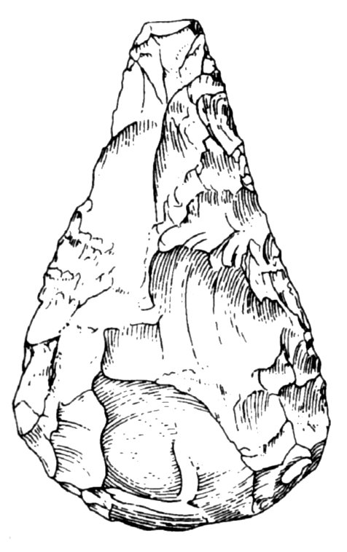

(b) The figure above shows an example of a tool used by Homo erectus. Name two
special features of this tool that identify it as part of the Acheulian tool kit.

(2)
(c) The development of upright bipedal locomotion in the hominids was made possible by the evolution of anatomical features. Name two such features.

(2)
Question 42 (total 10 marks)

A
B
C
D
E
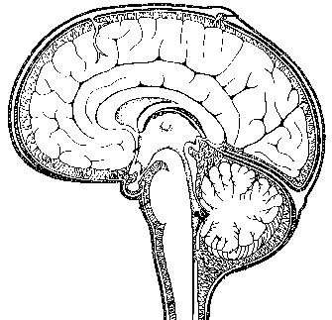

(a) Identify the labelled structures

A (1)
B (1)
C (1)
D (1)

(b) What is contained in the space labelled E?

(1)

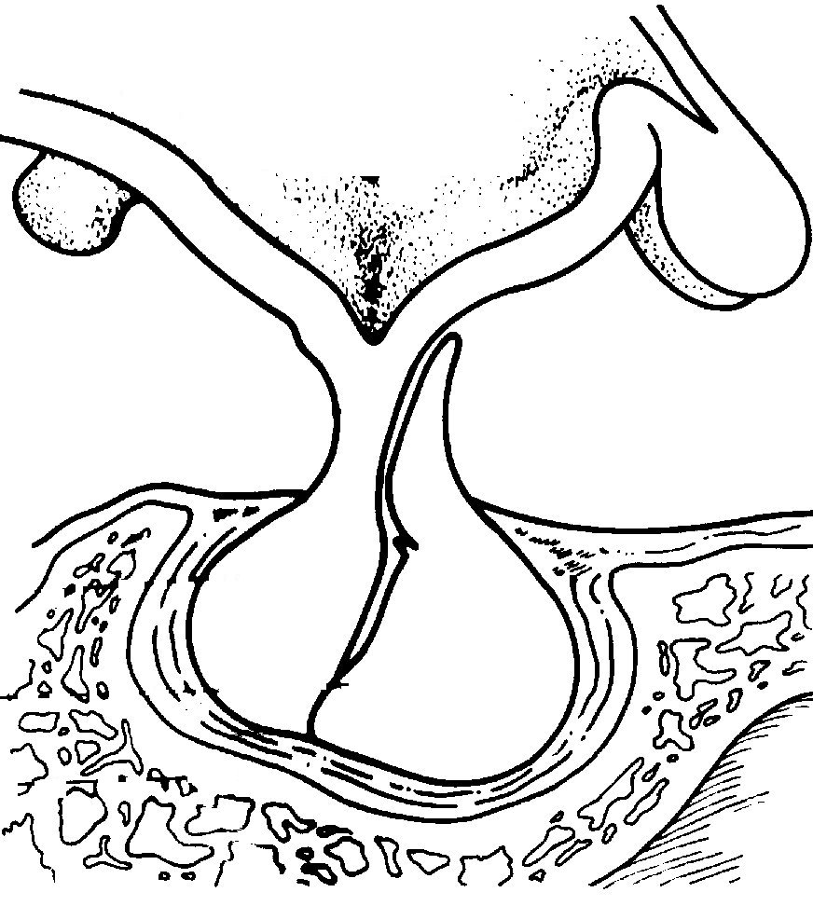
Posterior
Anterior
X
Y
F
Z

(c) The structure labelled F is the

(1)

(d) If a cut is made at line XY but only on the posterior side, what effect will this have on the function of structure Z?

(1)

(e) Explain why the cut resulted in this effect.

(2)

(f) Give one effect this will have on the body.

(1)

Question 43 (total 10 marks)

(a) What structures are responsible for detecting high blood pressure that occurs due to increased cardiac output?

(1)

(b) To reduce blood pressure, which branch of the nervous system would be stimulated?

(1)

(c) Give two examples of effectors for reducing blood pressure.

(2)

(d) Assuming that a person with high blood pressure is treated and has their blood pressure lowered, what effect will this have on the volume of lymphatic fluid produced?

(1)

(e) Explain why this effect on the volume of lymphatic fluid happens.

(2)

(f) Where does the lymph return to the blood?

(1)

(g) What role does the lymphatic system play in the body?

(2)

Question 44 (total 11 marks)

During an extended bike ride an athlete begins to sweat profusely, feels very hot, becomes red in the face and feels thirsty.

(a) What is the likely effect of profuse sweating on the salt concentration of the athlete’s body fluids?

(1)

(b) An increase in secretion of ADH is likely to occur in this situation. Explain how this increase in ADH is stimulated.

(2)

(c) What effect does the increase in ADH production have on the volume of urine produced?

(1)

(d) Explain the mechanism of this change in urine production with reference to specific components of the nephron.

(3)

(e) What causes the athlete to become red in the face and why is this of benefit?

(4)
Question 45 (total 12 marks)

A scientist was investigating the effectiveness of a newly developed drug, “Neurogen”, and its ability to improve recovery from nerve cell injury. The experiment was performed as described below:

Nerve cells were placed into culture medium (a solution containing nutrients to keep the cells alive and help them grow). An equal number of nerve cells (in culture medium) were transferred into nine test tubes and maintained under constant temperature and oxygen levels. Three of the test tubes received no further treatment. Of the remaining six test tubes, three tubes received a large, single dose of Neurogen whilst the remaining three tubes had a series of smaller doses of Neurogen added over a one week period.

After one month the growth of nerve axons in the test tubes was measured and the results are shown in the table below.

TREATMENT | Tube number | GROWTH OF NERVE AXONS  AFTER ONE MONTH (mm)
NEUROGEN  (Large, single dose) | 1  2  3 | 0.50  0.42  0.45
NEUROGEN  (Series of small doses) | 4  5  6 | 0.80  0.98  0.90
NO TREATMENT | 7  8  9 | 0.25  0.27  0.19

For the experiment described above:

(a) Identify ONE hypothesis being tested.

(2)

(b) What is the Dependent Variable?

(1)

(c) Based on the information given, list three variables that were controlled in this experiment.

(3)

(d) What is the purpose of having the three test tubes that did not receive any treatment with Neurogen?

(2)

(e) What two major conclusions could be drawn from these results?

(2)

(f) After this experiment, the scientist repeated the procedure three more times. Why would the scientist repeat the experiment so many times?

(2)

Question 46 (total 8 marks)

(a) Consider the drugs listed below and classify them as a STIMULANT or DEPRESSANT.

DRUG | STIMULANT/DEPRESSANT
ALCOHOL
NICOTINE
MARIJUANA
(3)

Examine the graph below that shows the relationship between blood alcohol concentration (BAC) and the relative risk of having a car crash. BAC is measured in g/100 ml. The relative risk is the number of times more likely that you will have a car crash than if you are sober
(i.e. BAC = 0).

Blood alcohol concentration
0.00
0.02
0.04
0.06
0.08
0.10
0.12
0.14
0.16
0.18
Relative risk of crash
0
5
10
15
20
25
30
35
Relative risk of car crash with increasing blood alcohol concentration

(b) How many times more likely are you, than if sober, to have a crash if your blood alcohol level is 0.12 g/100 mL.

(1)

(c) The maximum BAC allowed for the driver of a motor vehicle in WA was recently dropped from 0.08 to 0.05. What is the advantage of this?

(2)

(d) List two short-term effects of alcohol that may account for the pattern shown in the graph.

(2)
Question 47 (total 8 marks)

(a) Describe the difference in body shape between individuals adapted to cold environments and those adapted to hot environments.

Type of climate | Body shape
Cold
Hot
(2)

(b) In previous years the use of the term “geographic race” was common. What is meant by this term?

(2)

(c) Give two reasons why scientists today consider the use of the term “geographic race” to be inappropriate?

(2)

(d) Examine the table below that presents data on blood groups in relation to ethnic groups.

Type | Caucasians | African Americans | Chinese | Eskimos | Australian  Aborigines
O | 45% | 48% | 36% | 46% | 66%
A | 41% | 27% | 28% | 54% | 34%
B | 10% | 21% | 23% | 0% | 0%
AB | 4% | 4% | 13% | 0% | 0%

Given that Aborigines and Eskimos migrated into new areas from populated regions, how do you account for the absence of B or AB blood groups in these two ethnic groups?

(2)

Question 48 (total 11 marks)

Many scientists believe that increasing human populations are not compatible with the maintenance of a healthy environment. In particular, urbanisation is seen as a major threat.

(a) What is meant by the term URBANISATION?

(1)

(b) Identify two distinctly different harmful effects of urbanisation.

(2)

(c) Identify two ways in which the harmful effects of urbanisation can be reduced.

(2)

(d) Urbanisation is of particular significance in developing countries where the rate of population increase is very high. In the space below, sketch the population pyramid for a developing country such as India.
(2)

(e) As India undergoes demographic transition into a developed country, in what ways is this population pyramid expected to change?

(2)
(f) Give two strategies that could be employed by the Indian government to increase the likelihood of demographic transition?

(2)

END OF PART II
PART III (40 marks)

Answer ONE question from SECTION A and ONE question from SECTION B. Illustrate your answers with diagrams where appropriate. Up to TWO MARKS may be deducted for poorly structured answers: that is, answers in point form or diagrams not explained in the text of your answers. DO NOT WRITE ANSWERS IN PENCIL. Write your answers on the lined pages in your Question/Answer Booklet following the end of the questions.

SECTION A

ANSWER EITHER QUESTION 49 OR QUESTION 50—NOT BOTH

Question 49 (total 20 marks)

(a) Discuss the major differences between nervous and hormonal control of the human body.
(6)

(b) An individual’s spinal cord is severed below the level of the shoulder in a car accident. When examined, it is noticed that the patient’s leg moves in response to a sharp stimulus to the foot. Explain how this response can occur. Include in your answer details of specific components of the pathway involved in this response.
(7)

(c) After surgical removal of her pituitary gland due to a tumour, a woman’s menstrual cycles cease. Explain how treatment with luteinizing hormone (LH) and follicle stimulating hormone (FSH) could be used to restore her menstrual cycles.
(7)

OR

Question 50 (total 20 marks)

(a) The human skin performs a number of important functions. For five of these functions, discuss how they are achieved and in each case identify the structures involved.
(10)

(b) You are asked to prepare a vaccine for a disease. Outline three possible options for the preparation of the vaccine AND discuss how vaccines provide immunity for an individual.
(10)

SECTION B

ANSWER EITHER QUESTION 51 OR QUESTION 52—NOT BOTH

Question 51 (total 20 marks)
In the study of hominid evolution, some scientists believe that the early examples of the genus Homo such as Homo habilis and Homo erectus evolved from the Australopithecine apes of Africa.

(a) What is meant by the term EVOLUTION? Discuss THREE lines of evidence that support the theory of evolution.
(8)

(b) During the evolution of the Australopithecines into Homo, structural and cultural advances occurred. Discuss two physical and two cultural advances that Homo habilis exhibits when compared to Australopithecus africanus.
(4)

(c) Using evolutionary concepts, give an account of the evolutionary process by which Australopithecus africanus may have evolved into the new species Homo habilis.
(8)

OR

Question 52 (total 20 marks)

The earth is faced with a number of environmental problems of global proportions. These include:

- Greenhouse Effect
- Ozone Depletion
- Acid Rain

(a) Select two of the problems listed above and outline their causes, effects and possible solutions. (10)
Many people believe that the current environmental crisis facing our planet has its origin in the Agricultural Revolution.

(b) Outline the major events and advances that occurred during the Agricultural Revolution.
(6)

(c) What outcomes of the Agricultural Revolution may have laid the foundation for the current troubled status of the environment?
(4)

END OF PAPER
Check that you have written your Student Number on the front cover of this booklet.

ACKNOWLEDGEMENTS

Question 1: Figure modified from Shier, D, Butler, J., & Lewis, R. (2002). Hole’s human anatomy and physiology (9th ed). Boston: McGraw-Hill, Fig 20.4(a), p. 823.

Question 9: Figure from Tortora, G.J., & Anagnostakos, N.P. (1987). Principles of anatomy and physiology (5th ed). New York: Harper & Row, Fig17.3(c), p. 381.

Question 41: Figure from Relethford, J.H. (2000). The human species (4th ed). Mountain View, CA: Mayfield Publishing Company, Fig 13.17(a), p 353.

Question 42: Figure modified from Newton, T.J., & Joyce, A.P. (1995). Human perspectives: Book 2 (3rd ed.). Sydney: McGraw-Hill, Fig 24.2, p 290.

Question 46: Figure from Bowden, C., & Gilbert, S. (1995). Senior science series: Module two: Vehicles and drivers. Marron Publications, p 36.

Question 47: Figure taken from Sanson, P., & Pears, F. (Eds.). Biology two: Activity manual. Port Melbourne, Vic.: Heinemann, Table 3, p. 187.
Published by the Curriculum Council of Western Australia
27 Walters Drive
OSBORNE PARK WA 6017

